**Difference between JPA, Hibernate and Spring Data JPA**

# Introduction:

In modern enterprise Java development, handling data persistence is one of the most important tasks. There are several ways to do it, but over time, the Java Persistence API (JPA), Hibernate (a JPA implementation), and Spring Data JPA (a Spring abstraction over JPA) have emerged as dominant technologies. Understanding the difference between them is crucial for designing scalable and maintainable applications.

# What is JPA?

Java Persistence API (JPA) is a specification (JSR 338) provided by Oracle for accessing, persisting, and managing data between Java objects and a relational database. JPA is just a set of interfaces and does not provide any implementation. Developers need to choose a provider like Hibernate, EclipseLink, or OpenJPA that implements this specification. The main goal of JPA is to standardize the Object-Relational Mapping (ORM) in Java and to reduce the complexity of data persistence.

# Key Features of JPA

- Annotation-based configuration  
- Entity mapping to tables  
- JPQL (Java Persistence Query Language)  
- Transaction management  
- Lazy and Eager fetching  
- Cascading operations  
- Embedded objects

# What is Hibernate?

Hibernate is one of the most popular ORM tools in the Java ecosystem. It is an open-source implementation of JPA. Hibernate provides a robust and flexible framework to map Java classes to database tables. Even before JPA was introduced, Hibernate existed with its own proprietary APIs. With the introduction of JPA, Hibernate evolved to support the standard JPA specification as well. Developers can still use native Hibernate features beyond JPA when more control is needed.

# Key Features of Hibernate:

- Implements JPA specification  
- Supports native HQL (Hibernate Query Language)  
- Built-in caching (first-level and second-level)  
- Automatic table generation  
- Database vendor independence  
- Flexible transaction handling

# What is Spring Data JPA?

Spring Data JPA is a part of the Spring Data project, which aims to simplify data access layers. It is not a JPA implementation itself, but an abstraction over JPA (and Hibernate underneath) to reduce boilerplate code. It uses repository interfaces and custom method naming conventions to generate queries at runtime. Spring Data JPA handles a lot of the repetitive CRUD code and transaction management for developers.

# Key Features of Spring Data JPA:

- Uses JpaRepository, CrudRepository  
- Query generation from method names  
- Integration with Spring Boot  
- Support for pagination and sorting  
- Automatic transaction management  
- Easily extensible

# Comparison with Example Code:

Let's compare how a simple operation like saving an Employee entity differs across Hibernate and Spring Data JPA:  
  
Hibernate:  
public Integer addEmployee(Employee employee) {  
 Session session = factory.openSession();  
 Transaction tx = null;  
 Integer employeeID = null;  
 try {  
 tx = session.beginTransaction();  
 employeeID = (Integer) session.save(employee);  
 tx.commit();  
 } catch (HibernateException e) {  
 if (tx != null) tx.rollback();  
 e.printStackTrace();  
 } finally {  
 session.close();  
 }  
 return employeeID;  
}  
  
Spring Data JPA:  
@Autowired  
private EmployeeRepository employeeRepository;  
  
@Transactional  
public void addEmployee(Employee employee) {  
 employeeRepository.save(employee);

**Comparison Table:**

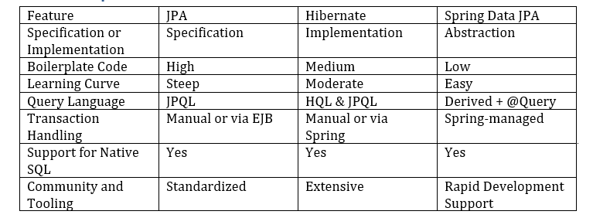

# Practical Demonstration: Employee Entity Example:

## 1. Hibernate Implementation

In a Hibernate-based application, we typically need to set up the SessionFactory, manage sessions and transactions explicitly. Below is an example of how an Employee object is persisted using native Hibernate APIs:

@Entity  
@Table(name = "employee")  
public class Employee {  
 @Id  
 @GeneratedValue(strategy = GenerationType.IDENTITY)  
 private Integer id;  
  
 private String name;  
 private String role;  
 private double salary;  
  
 // Getters and setters  
}  
  
public Integer addEmployee(Employee employee) {  
 Session session = factory.openSession();  
 Transaction tx = null;  
 Integer employeeID = null;  
 try {  
 tx = session.beginTransaction();  
 employeeID = (Integer) session.save(employee);  
 tx.commit();  
 } catch (HibernateException e) {  
 if (tx != null) tx.rollback();  
 e.printStackTrace();  
 } finally {  
 session.close();  
 }  
 return employeeID;  
}

Expected Output (Console):

Hibernate: insert into employee (name, role, salary) values (?, ?, ?)

## 2. Spring Data JPA Implementation:

Spring Data JPA abstracts most of the boilerplate. Only an interface extending JpaRepository and minimal service code is needed:

@Entity  
@Table(name = "employee")  
public class Employee {  
 @Id  
 @GeneratedValue(strategy = GenerationType.IDENTITY)  
 private Integer id;  
  
 private String name;  
 private String role;  
 private double salary;  
  
 // Getters and setters  
}  
  
public interface EmployeeRepository extends JpaRepository<Employee, Integer> {  
}  
  
@Service  
public class EmployeeService {  
 @Autowired  
 private EmployeeRepository employeeRepository;  
  
 @Transactional  
 public void addEmployee(Employee employee) {  
 employeeRepository.save(employee);  
 }  
}

Expected Output (Console):

Hibernate: insert into employee (name, role, salary) values (?, ?, ?)

# Conclusion:

To summarize, JPA is just a standard, Hibernate is an implementation of that standard, and Spring Data JPA is a higher-level abstraction to make development easier. Each has its own use case: for fine-grained control and customizations, Hibernate is powerful; for rapid development, Spring Data JPA is more convenient. A good developer should be comfortable using all three based on the context of the application being developed. When deciding between raw Hibernate and Spring Data JPA, it’s important to consider development speed vs. flexibility. Hibernate gives full control over session management and queries, while Spring Data JPA focuses on reducing effort through conventions.